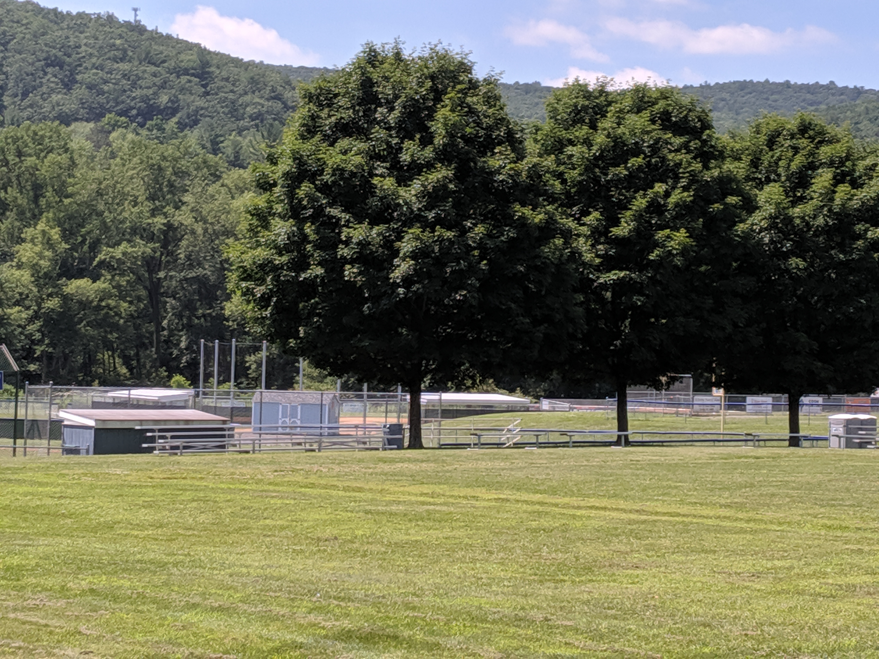
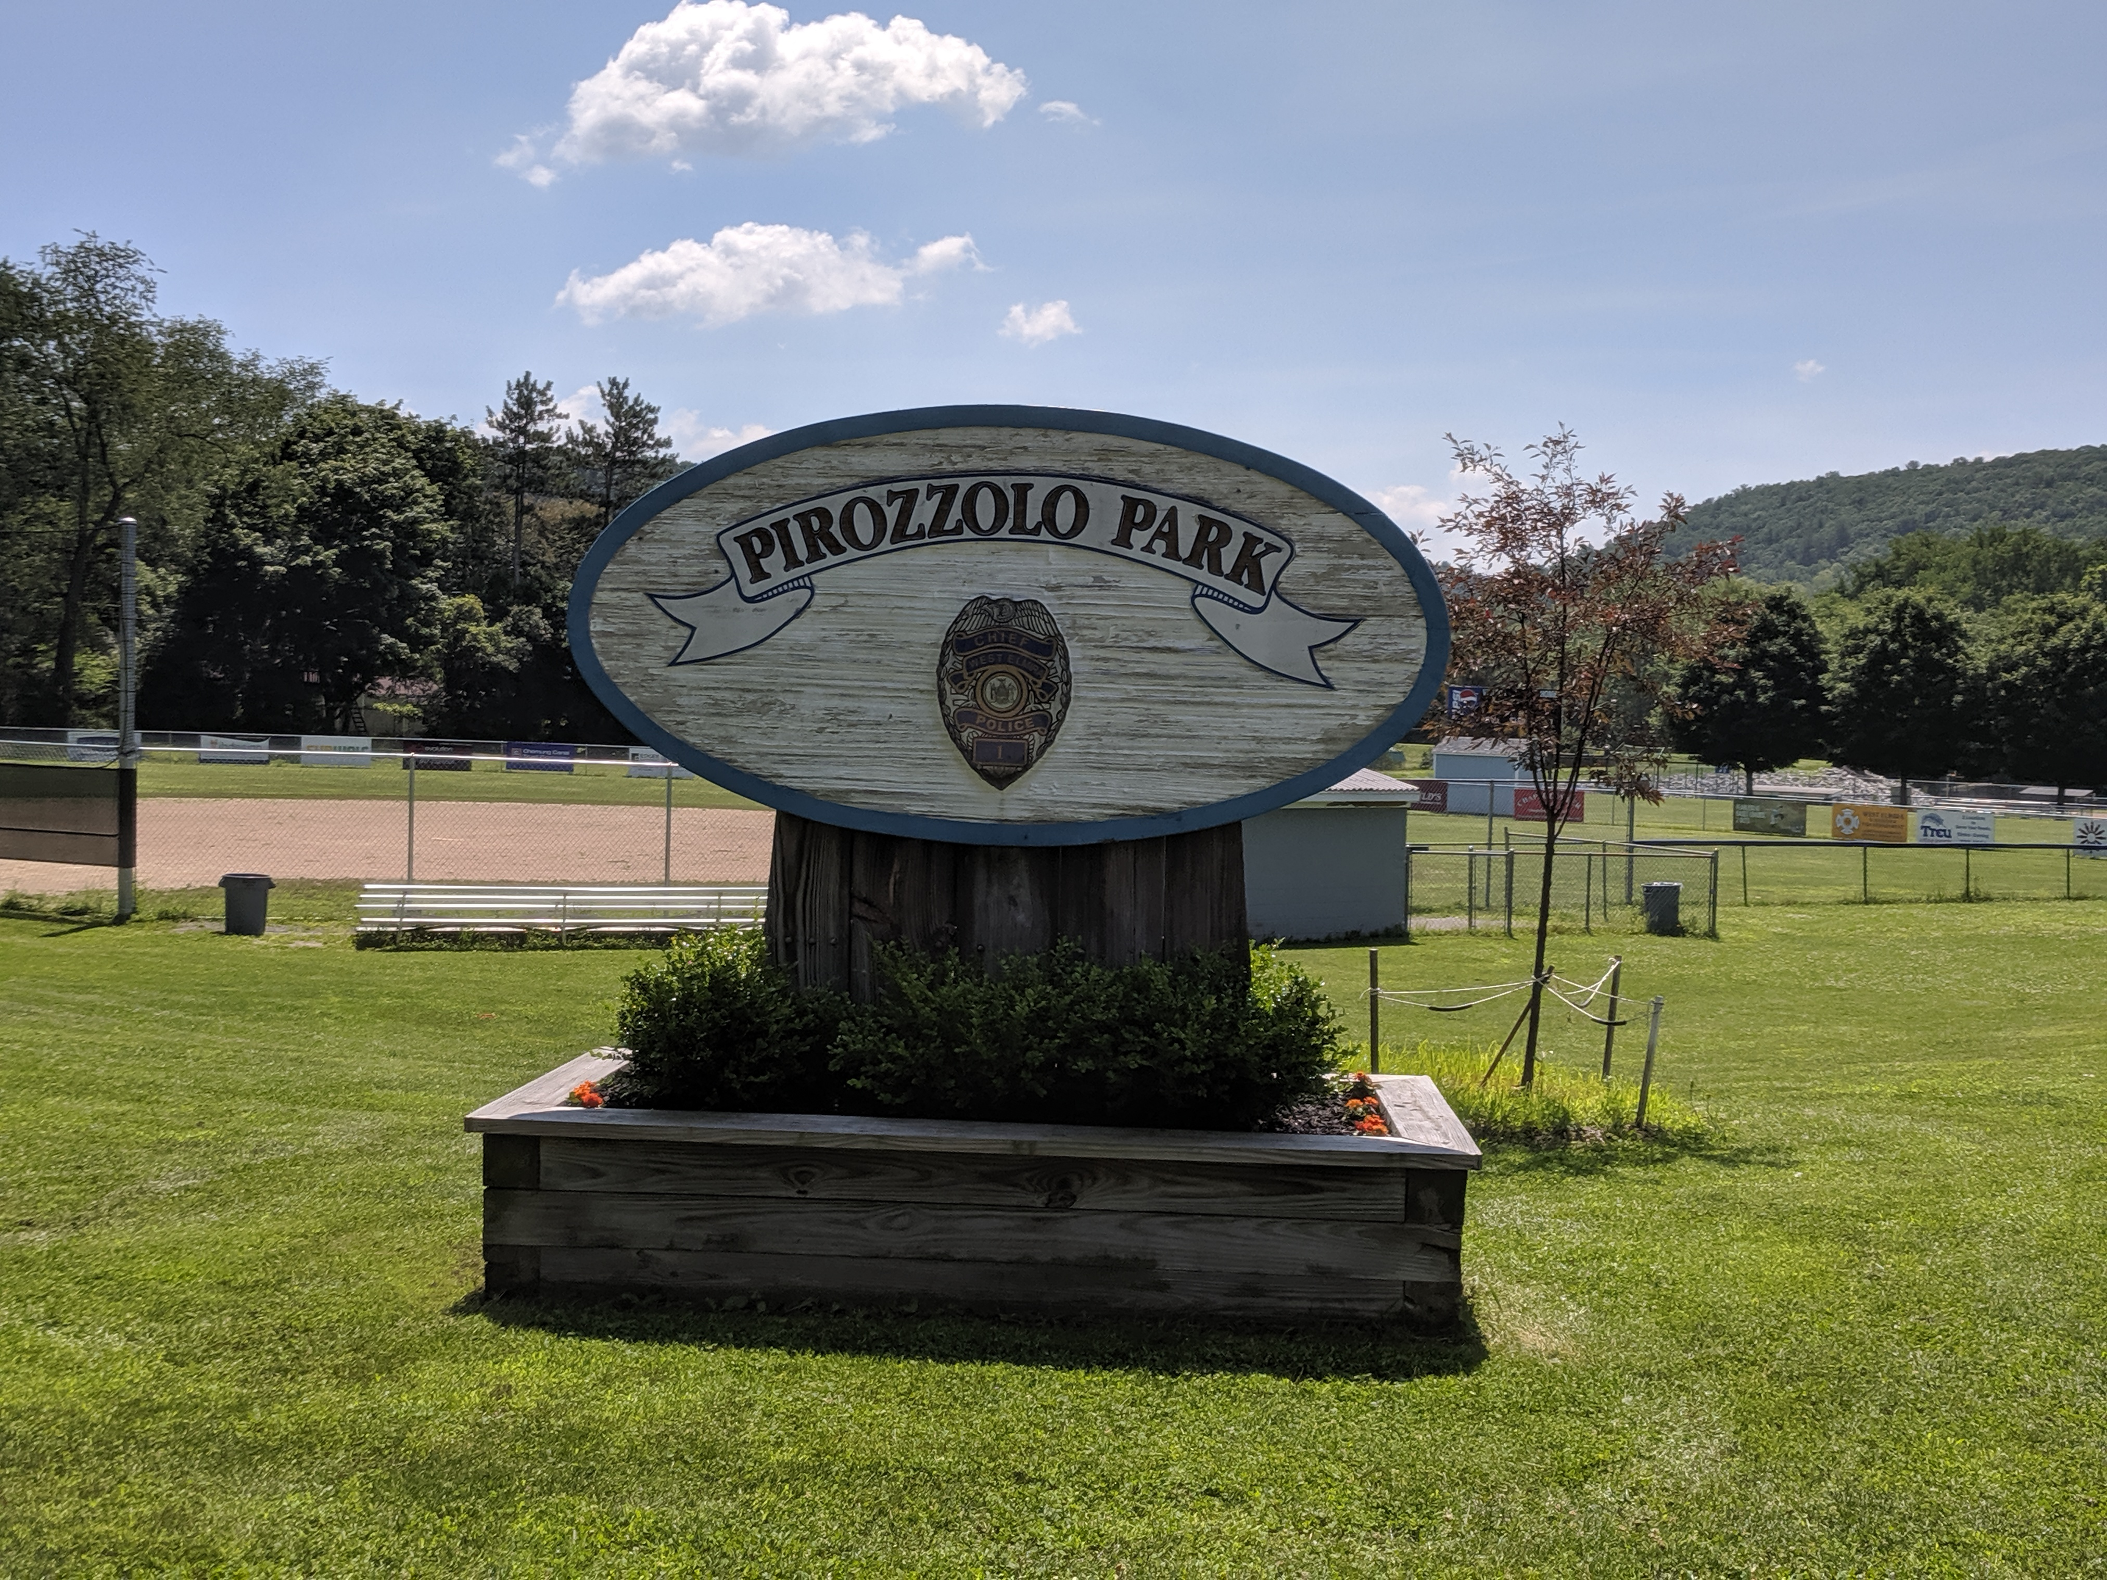
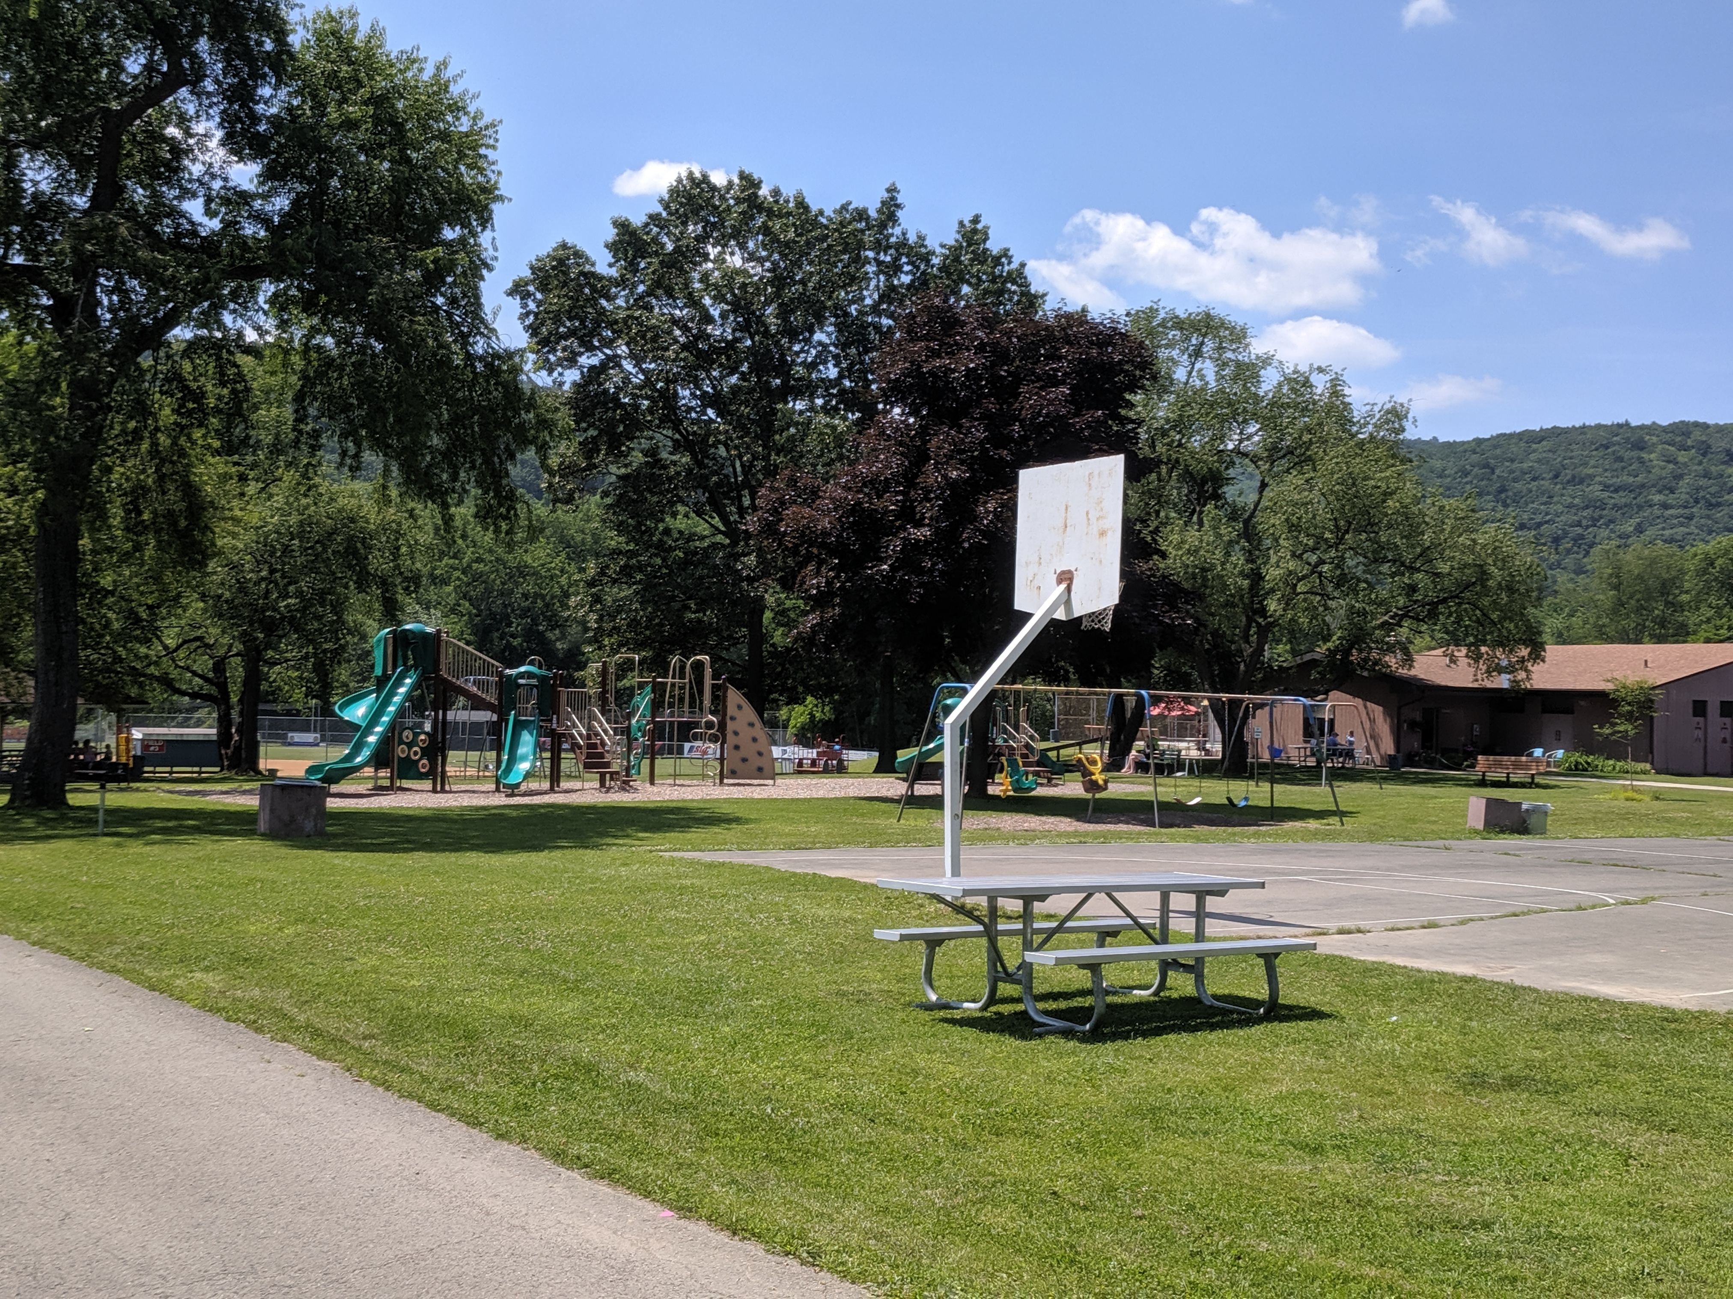
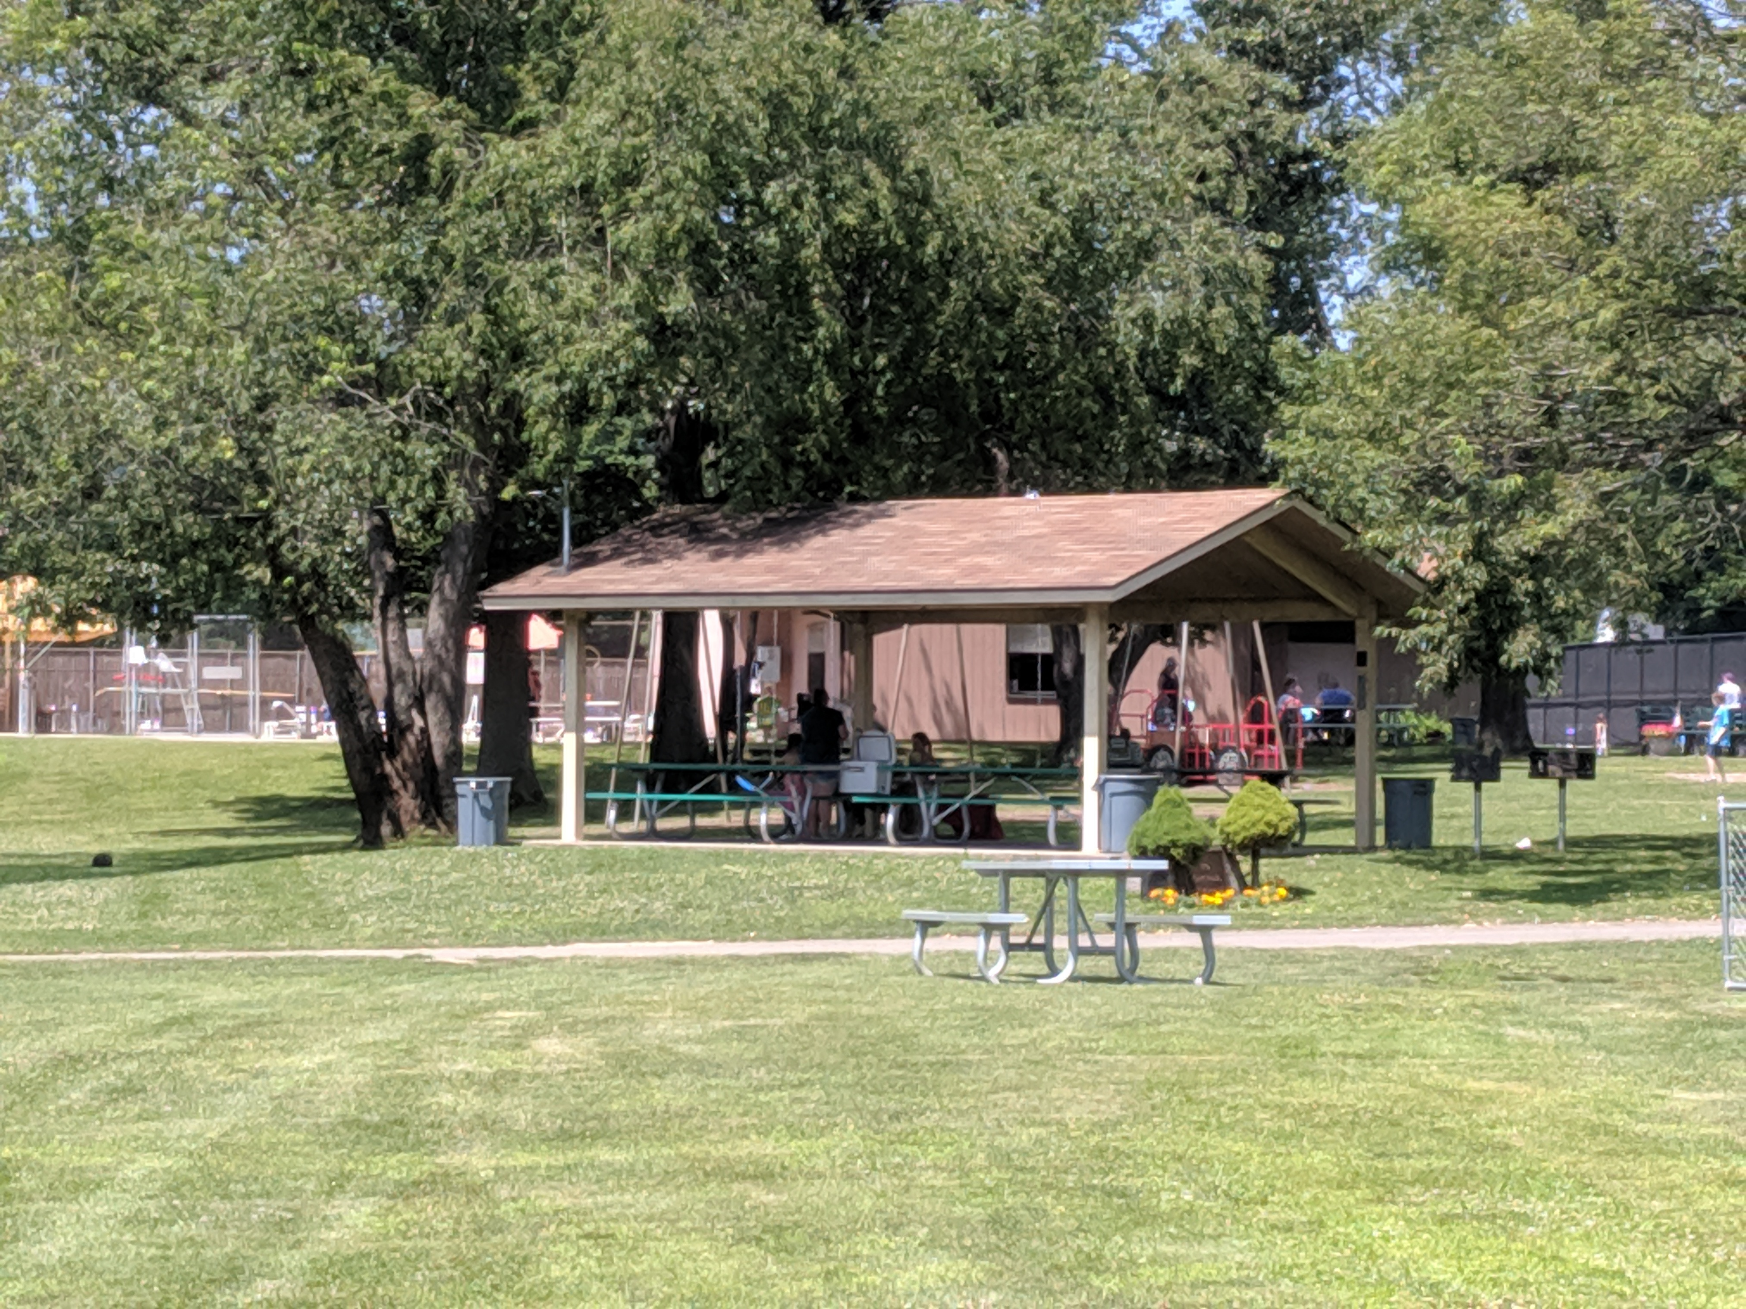

Saturday October 19th

The GREAT West Elmira Picnic & Field Day!
  - Come Play, Eat, Meet Friends, Make Art & More!
COME ONE, COME ALL!!!  It’s an old-fashioned dish-to-pass potluck with lots of time (grass, fields, facilities!) to play your favorite games with family, friends, neighbors… AND… opportunities to make BIG ART – think sidewalk splash painting, string sculptures & more!  Noon ‘til Done!  WHAT TO BRING???  Your Favorite Picnic Fare to Share (labeled for our friends w/allergies)  Picnic Ware, Chair, Blanket, etc.  Sports/Games Equipment  Riding Toys for Little Tykes  Enthusiasm, Curiosity, Good Will, too!  NO ALCOHOL PLEASE |  | Come Share Your Favorite Picnic Fare!  Come Play Your Favorite Family Games!

